Chapter 8, Solution 32.

For the circuit in Fig. 8.80, find v(t) for t > 0.

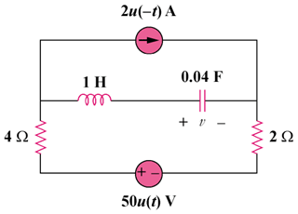

Figure 8.80
For Prob. 8.32.

Solution

For t = 0-, the equivalent circuit is shown below.

2 A
+ −

v

6 Ω

i

i(0-) = 0, v(0-) = -2x6 = -12V

For t > 0, we have a series RLC circuit with a step input.

α = R/(2L) = 6/2 = 3, ω_{o} = 1/

s =

Thus, v(t) = V_{f} + [(Acos4t + Bsin4t)e^{-3t}]

where V_{f} = final capacitor voltage = 50 V

v(t) = 50 + [(Acos4t + Bsin4t)e^{-3t}]

v(0) = -12 = 50 + A which gives A = -62

i(0) = 0 = Cdv(0)/dt

dv/dt = [-3(Acos4t + Bsin4t)e^{-3t}] + [4(–Asin4t + Bcos4t)e^{–3t}]

0 = dv(0)/dt = -3A + 4B or B = (3/4)A = –46.5

v(t) = {50 + [(–62cos4t – 46.5sin4t)e^{–3t}]} V

